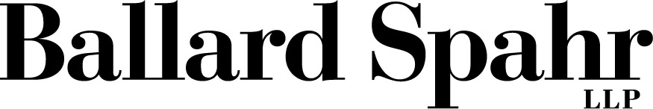 | FOR IMMEDIATE RELEASE
Robin Ireland
Director of Communications
215.864.8674
302.668.6710
irelandr@ballardspahr.com

WASHINGTON, D.C. (November 14, 2018) – At our clients’ request, the following statement regarding CNN, et al. v. Trump, et al. is issued on behalf of The Associated Press; Bloomberg L.P.; First Look Media Works, Inc.; FOX News; Gannett; National Press Club Journalism Institute; NBC News; The New York Times Co.; POLITICO; Press Freedom Defense Fund; E.W. Scripps Company; USA TODAY NETWORK; and The Washington Post:
Whether the news of the day concerns national security, the economy, or the environment, reporters covering the White House must remain free to ask questions. It is imperative that independent journalists have access to the President and his activities, and that journalists are not barred for arbitrary reasons. Our news organizations support the fundamental constitutional right to question this President, or any President. We will be filing friend-of-the-court briefs to support CNN’s and Jim Acosta’s lawsuit based on these principles.
# # #
CONTACT:

Charles D. Tobin, Partner Jay Ward Brown, Partner
Washington, D.C. Washington, D.C.
202.661.2218 202.508.1136 tobinc@ballardspahr.com brownjay@ballardspahr.com

Chad R. Bowman, Partner
Washington, D.C.
202.508.1120
bowmanchad@ballardspahr.com

